**Palindrome Number:**

#include <stdio.h>

int main() {

int num, reversedNum = 0, originalNum, remainder;

printf("Enter a number: ");

scanf("%d", &num);

originalNum = num;

while (num > 0) {

remainder = num % 10;

reversedNum = reversedNum * 10 + remainder;

num /= 10;

}

if (reversedNum == originalNum)

printf("%d is a palindrome number.\n", originalNum);

else

printf("%d is not a palindrome number.\n", originalNum);

return 0;

}

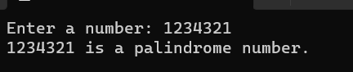

**Buzz Number:**

#include <stdio.h>

int main() {

int num;

printf("Enter a number: ");

scanf("%d", &num);

if ((num % 7 == 0) || (num % 10 == 7))

printf("%d is a buzz number.\n", num);

else

printf("%d is not a buzz number.\n", num);

return 0;

}

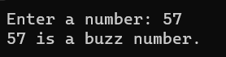

**Neon Number:**

#include <stdio.h>

int main() {

int num, square, sumDigits = 0;

printf("Enter a number: ");

scanf("%d", &num);

square = num * num;

while (square > 0) {

sumDigits += square % 10;

square /= 10;

}

if (sumDigits == num)

printf("%d is a neon number.\n", num);

else

printf("%d is not a neon number.\n", num);

return 0;

}



**Strong Number:**

#include <stdio.h>

int main() {

int num, originalNum, sumFactorials = 0;

printf("Enter a number: ");

scanf("%d", &num);

originalNum = num;

while (num > 0) {

int digit = num % 10;

int factorial = 1;

for (int i = 1; i <= digit; i++)

factorial *= i;

sumFactorials += factorial;

num /= 10;

}

if (sumFactorials == originalNum)

printf("%d is a strong number.\n", originalNum);

else

printf("%d is not a strong number.\n", originalNum);

return 0;

}

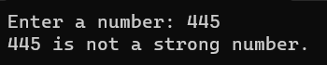

**Strange Number:**

#include <stdio.h>

int main() {

int num, sum = 0;

printf("Enter a number: ");

scanf("%d", &num);

for (int i = 1; i <= num / 2; i++) {

if (num % i == 0)

sum += i;

}

if (sum == num)

printf("%d is a strange number.\n", num);

else

printf("%d is not a strange number.\n", num);

return 0;

}



**Prime Number:**

#include <stdio.h>

int main() {

int num, i, prime = 1;

printf("Enter a number: ");

scanf("%d", &num);

for(i= 2; i < num; i++) {

if((num % i) == 0) {

prime = 0;

}

}

if (prime)

printf("Prime number.\n");

else

printf("Not a prime number.\n");

return 0;

}



**Armstrong Number:**

#include <stdio.h>

#include <math.h>

int main(void)

{

int num, original,digit, sum=0,dig = 0;

scanf("%d",&num);

original=num;

int i=num;

while (i!=0)

{

dig++;

i/=10;

}

int j=num;

while(j!=0)

{

digit = j%10;

sum += pow (digit,dig);

j /=10;

}

if (original == sum)

{

printf("Armstrong Number");

}

else

printf("Not Armstrong");

return 0;

}



**Adam number:**

#include <stdio.h>

int main() {

int num, square, reversed, reversedSquare, temp;

printf("Enter a number: ");

scanf("%d", &num);

square = num * num;

reversed = 0;

temp = num; // Store the original number in a temporary variable

while (temp > 0) {

reversed = reversed * 10 + (temp % 10);

temp /= 10;

}

reversedSquare = reversed * reversed;

if (reversedSquare == square) { // Compare with the square of the original number

printf("%d is an Adam number.\n", num);

} else {

printf("%d is not an Adam number.\n", num);

}

return 0;

}

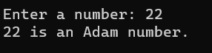

**Duck number:**

#include <stdio.h>

int main(void)

{

int num, duck=0, digit;

scanf("%d", &num);

while (num!=0)

{

digit = num % 10;

if (digit==0)

{

duck = 1;

break;

}

num /= 10;

}

if (duck)

{

printf("Duck Number");

}

else

printf("Not Duck");

return 0;

}



**Automorphic Number:**

#include <stdio.h>

int main() {

int num, square, numDigits, lastDigits;

printf("Enter a number: ");

scanf("%d", &num);

square = num * num;

numDigits = 0;

lastDigits = 0;

int temp = num;

while (temp > 0) {

numDigits++;

temp /= 10;

}

int divisor = 1;

for (int i = 0; i < numDigits; i++)

divisor *= 10;

lastDigits = square % divisor;

if (lastDigits == num)

printf("%d is an Automorphic number.\n", num);

else

printf("%d is not an Automorphic number.\n", num);

return 0;

}

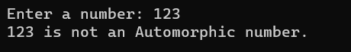

**Sunny number:**

#include<stdio.h>

#include<math.h>

int main()

{

int num;

printf("Enter the number:");

scanf("%d",&num);

double root;

root=sqrt(num+1);

if((int)root==root)

printf("It is a Sunny Number.");

else

printf("It is not a Sunny Number.");

}

